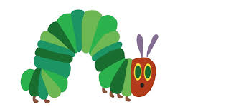

* Start by sharing the story if you have a copy of the book.

You could also watch the story on youtube. <https://www.youtube.com/watch?v=75NQK-Sm1YY>

* Draw one picture of an item from the story on a post-it note or small piece of paper. When you have a few of these, stick them around the house or garden and ask your child to go and find a certain picture. You could then ask for 2 things e.g ‘Find the apple and the orange.’ To change the game you could ask for a colour ‘Find me something red’.
* Draw a story map (pictures that show what happened in the story in order) and then use it to re-tell the story together.
* Make up a story with your child pretending to eat different foods and use the same words as in the story e.g. Jack ate one banana – *but he was still hungry*. Then he ate an apple and a piece of bread – *but he was still hungry*.
* At snack times or meal times use lots of different words for eating e.g. munching, chewing, nibbling, chomping, biting, slurping.
* Make a fruit salad together. Take photos of each step then look at the photos later and talk about what you did.
* When making your fruit salad you could help your child to learn names for different parts of the fruit e.g. peel, skin, stalk, pip, seed, core. Also slice, chunk, segment. You could also use words to describe the fruits e.g. crunchy, squishy, juicy, sweet, hard, smooth, sticky.
* Draw some small caterpillars, cut out and play hide & seek with them. Can your child put the caterpillar in/on/under/behind/in front of objects?

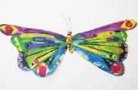

* Look on the internet and find photos of lots of things that can fly including butterflies, bees, birds and even planes!
* Collect a few items – some food, some not food. Let your child help you to sort them – you could put all the things we can **eat** into a shopping bag and the other items into a box.

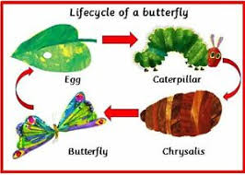

* Use playdough, salt dough or junk materials to make the egg, leaf, caterpillar, chrysalis, butterfly and talk about what happened first, next, then…..